Resolution

# Bug Zero Charge been solved

This document presents a screenshot of simplified code that can show that are bugs that was reported regarding the charge appearing to be zero during the checkout has been resolved. The test is performed without any user input and all the methods call are automated. As there is no method that can be used to check the charge of the room without changing the code, the print output is taken as a confirmation of the bugs that has been reported.

The automated test done to shoe that the bug that lead to the charge for service to be zero when user try to check out is demonstrated in the screenshots has been solved. In figure 1, 2 and 3 the UAT test done to show that the bug has been solved. The figure 4 automate this process for 20 times using a loop to generate random variable that is been used as an input and all the test shows that the bug is no longer present in application.

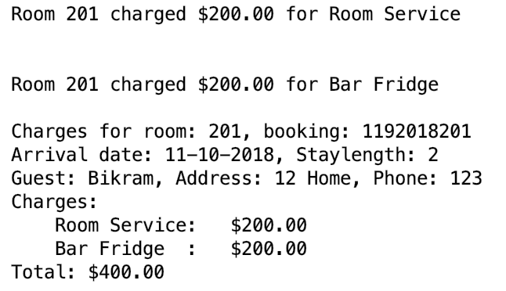

Figure 1: Solution of bug zero charge case 1.

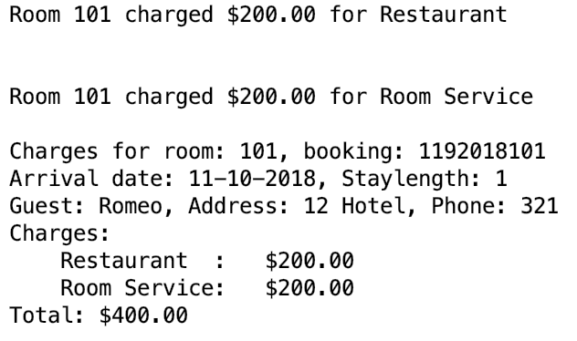

Figure 2: Solution of bug zero charge case 2.

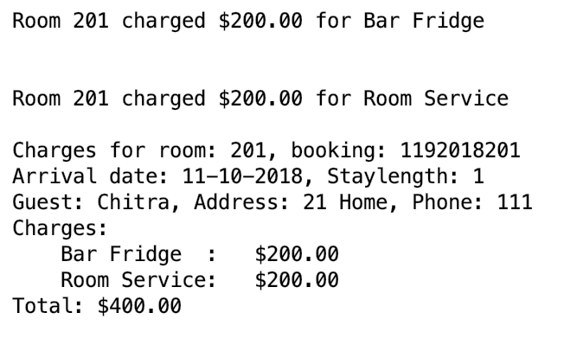

Figure 3: Solution of bug zero charge case 3.

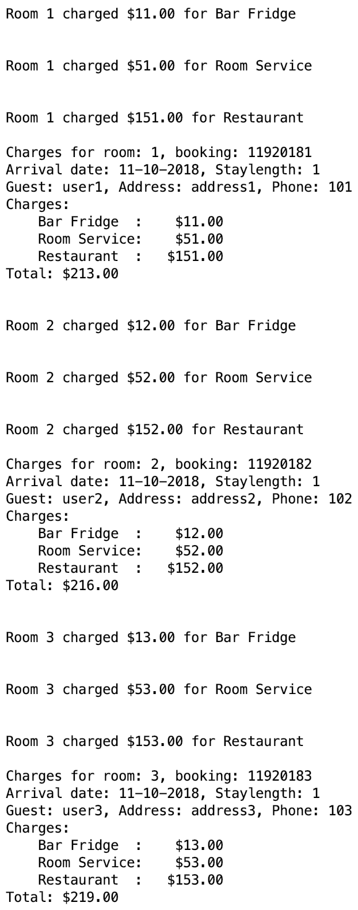 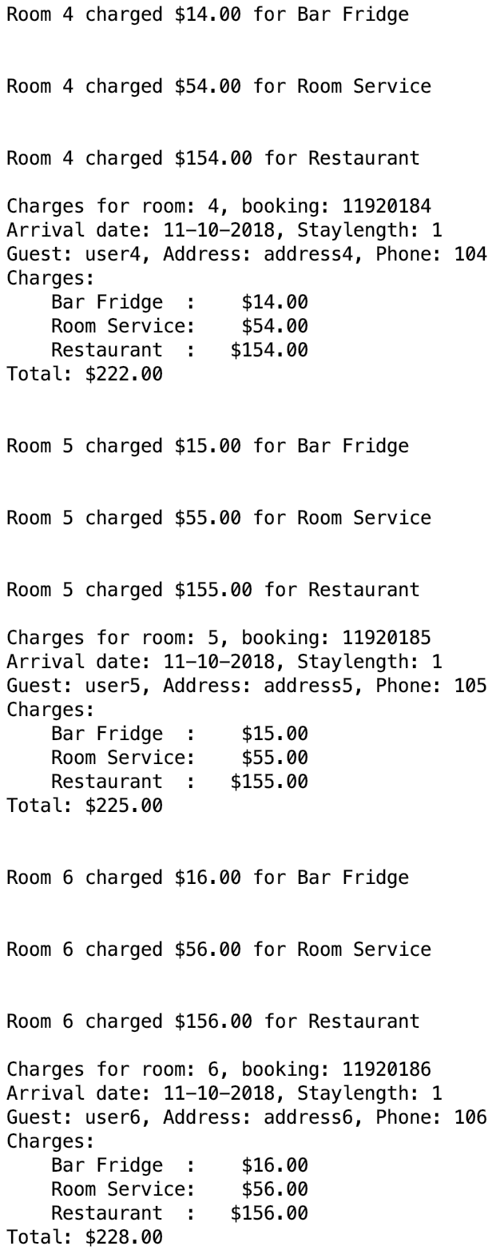 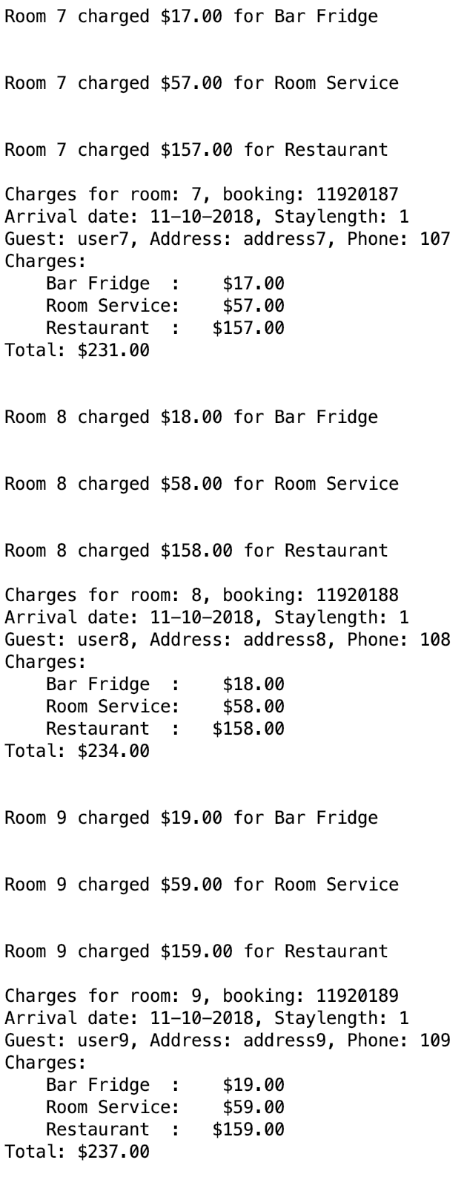 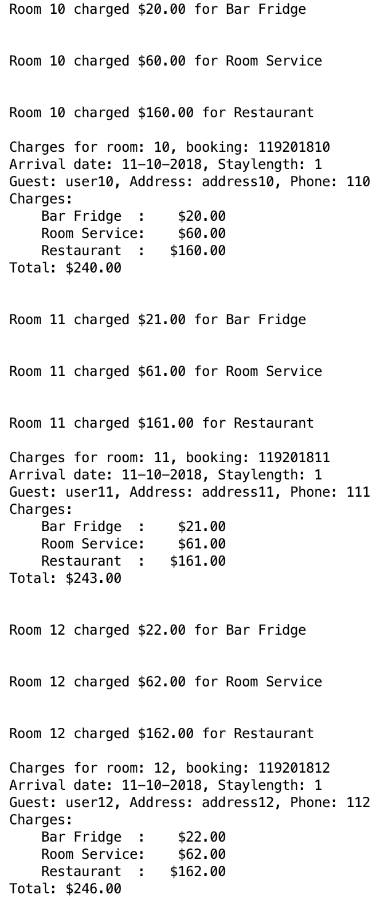 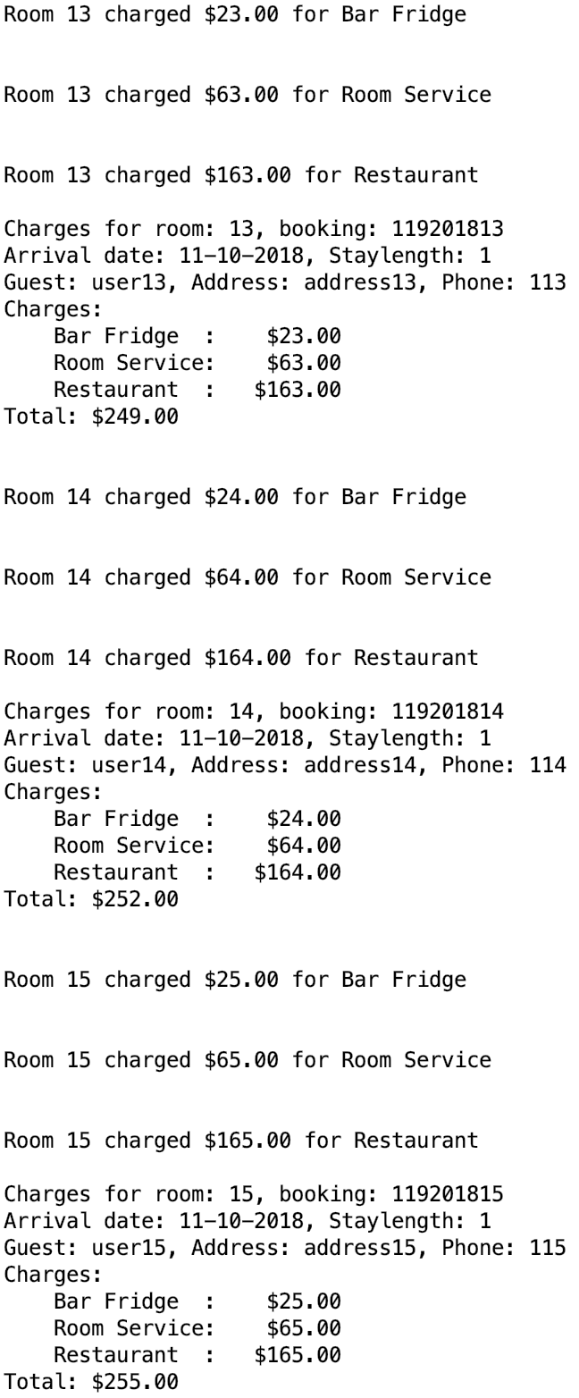 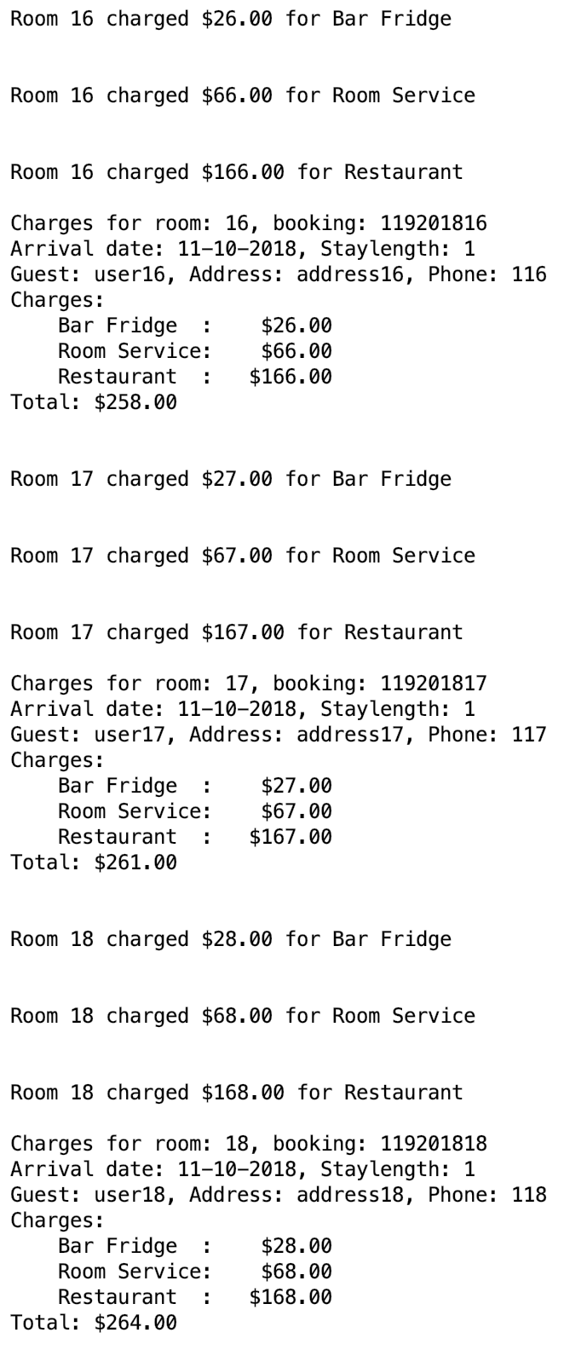 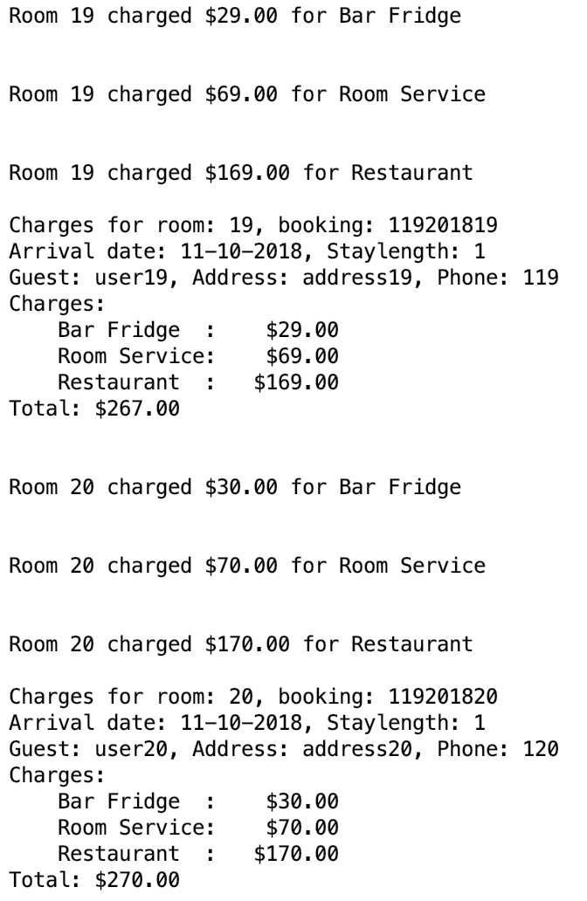

Figure 4: Solution of bug Zero charge case 4